auto area = getLocalBounds();

recordButton.setBounds(area.removeFromTop(40).removeFromLeft(100).reduced(10));

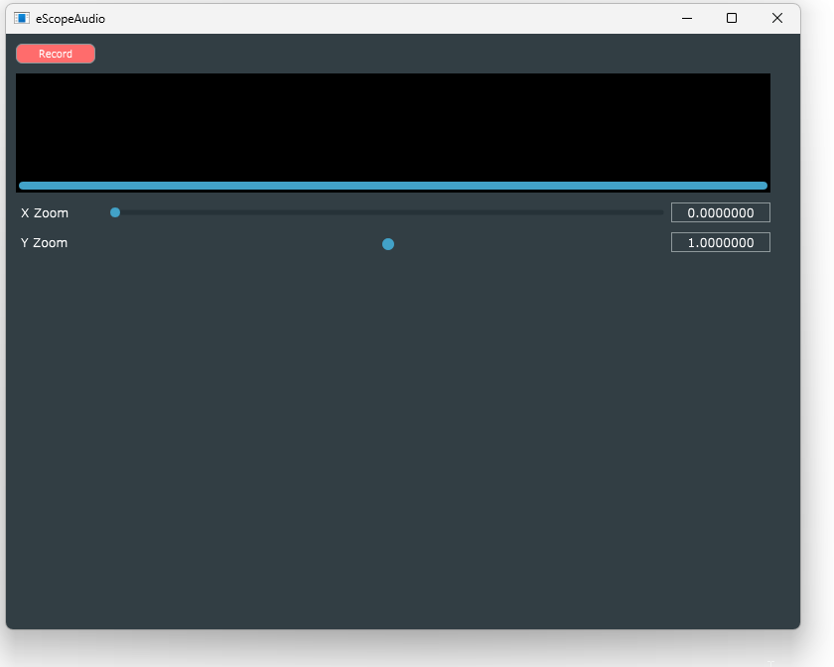

10

10

10

10

**100**

**40**



170

getWith() -10 -30

120

40

100

getWidth()

10

300



recordingThumbnail.setBounds(10,40,getWidth()-40,120);

xZoomSlider.setBounds(100, 170, getWidth() - 130, 20);

xZoomLabel.setBounds(10, 170, 90, 20);